Photo editing with PhotoPlus

There are a number of easy ways to edit photos in PhotoPlus.

Cropping

You can easily crop unwanted detail off a photo.

- Select the rectangular marquee tool and drag out a rectangle around the area of the photo you want to keep.

Rectangular marquee tool
Area select with marquee tool
Once you have selected the area to keep, choose the Image menu, then Crop to Selection.
- If you want to keep the original uncropped image you can select the area you want to crop with the Rectangular Lasso tool, but then choose Copy from the Edit menu.

- Now select File and New. PhotoPlus will display the New dialog box with the size set to clipboard:
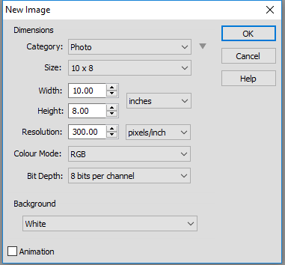
The New dialog box will automatically be set to the correct size for the part of the image you copied.
- Click OK on the New dialog box, then choose Paste from the edit menu and the part of the image you copied will paste into the new file.

Resizing

Resizing an image is also an important technique to ensure your image is the right size for how it will be used and to ensure file sizes are kept to a minimum.

- Choose the Image menu, then the Image size option. This will display the Image Size dialog box – see below:

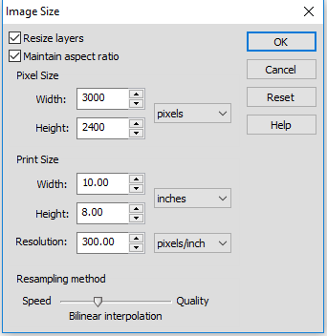
This picture is 10” × 8”. This might be big enough for use on an A4 poster, but may be too small for an A3 poster. For use on a website this size may be larger than required.
Resolution is 300dpi – fine for printing but unnecessarily high for web page use.
Selecting irregular shapes

The crop method only allows you to select a rectangular shape. To select an irregular shape such as the outline of a person’s head you need to use the Lasso tool to ‘cut out’ part of the image.

By clicking and holding on the Lasso tool the submenu will pop out and you can choose the Polygonal Lasso or the Magnetic Lasso.

With the Polygonal Lasso you have to click each time you want to create a ‘bend’ in the lasso; the Magnetic Lasso automatically follows the outline of a shape as long as it contrasts well with the background. The Magnetic Lasso is easier to use but with patience you can achieve a better result with the Polygonal Lasso.

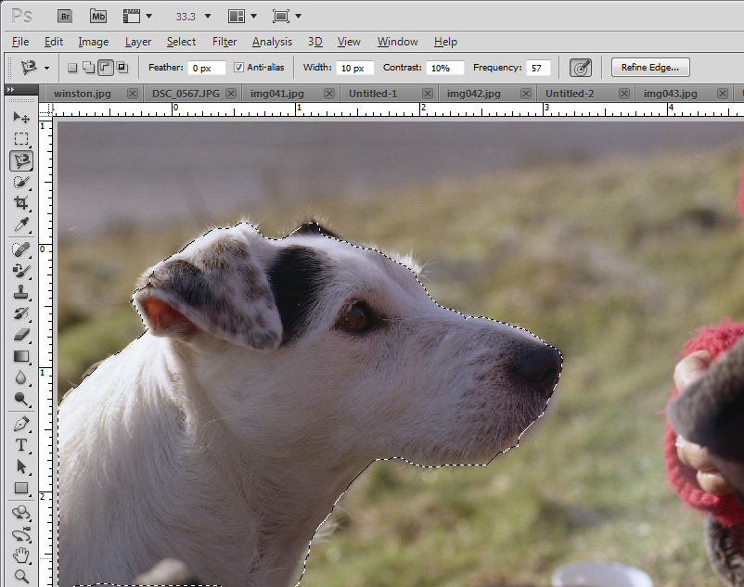
The head of the dog has been selected using the Polygonal Lasso tool.
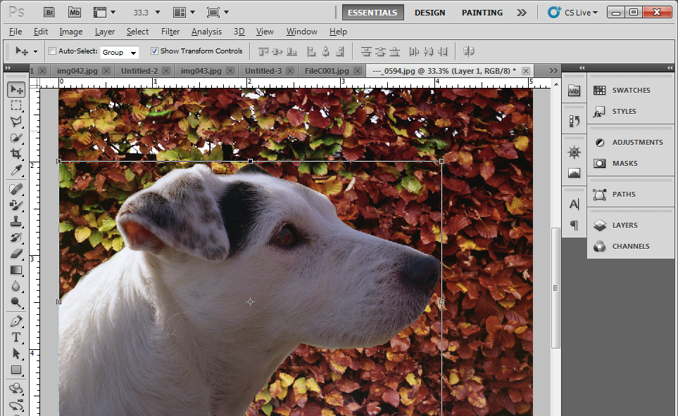
Using copy and paste the head of the dog has been copied onto a different background.
Tasks

Open some images you have available and practise the following:

- Crop the image, removing the part of the image you do not require.
- Crop the image, creating a new version of the image, leaving the original unchanged.
- Find a suitable image with a character or object you can cut out using the Polygonal Lasso tool as described above and paste it into a background image.
- Take a photo of a few of your friends and use PhotoPlus to select their heads and swap them onto different bodies.
- Resize an image so it is suitable for displaying at a small size on a website, about 2 inches wide.

